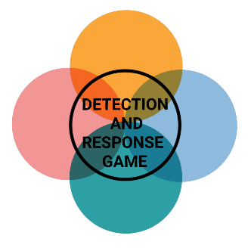

**PRIVILEGE ESCALATION**



**PRIVILEGE ESCALATION**



**PRIVILEGE ESCALATION**



**PRIVILEGE ESCALATION**

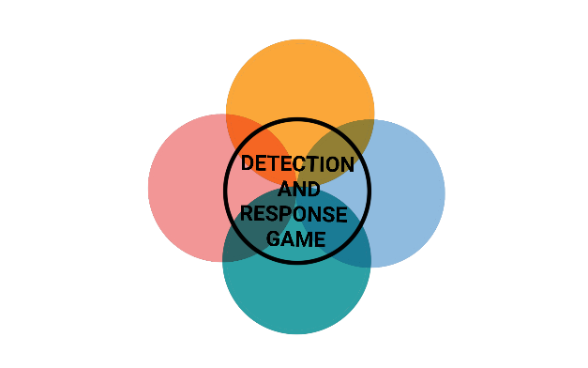

**INITIAL ACCESS**



**INITIAL ACCESS**



**INITIAL ACCESS**



**INITIAL ACCESS**



**PRIVILEGE ESCALATION**



**PRIVILEGE ESCALATION**



**PRIVILEGE ESCALATION**



**PRIVILEGE ESCALATION**

**WINDOWS KERNEL EXPLOITATION**

The hacker found a not updated system that allows a Windows kernel exploit.

PREVENTION

Regular updates

DETECTION

Vulnerability scanner

**LOCAL ACCOUNTS**

The hacker found a password that was saved in a text file on an employee's laptop and used it to access the local account.

PREVENTION

Password manager

DETECTION

Regular audits of local system accounts

**DLL HIJACKING**

The hacker discovered a missing DLL that he can replace with a malicious file, the DLLs are executed when Windows starts.

PREVENTION

Disabling DLL loading from remote network shares

DETECTION

Monitor DLL locations

**DEFAULT ACCOUNTS**

The hacker found software with administrator rights on the system which still has the default password.

PREVENTION

Password policies

DETECTION

Monitor whether default accounts have been activated or logged into



**INITIAL ACCESS**



**INITIAL ACCESS**



**INITIAL ACCESS**



**INITIAL ACCESS**

**UNQUOTED SERVICE PATHS**

The hacker finds an unquoted service path exploit that can be used to execute binaries in the same folder.

PREVENTION

Enclose the path in quotes

DETECTION

Wmic search

**PRINTER NIGHTMARE**

The hacker found several devices with the printer nightmare weak point which enabled remote code execution through the Windows spooler service.

PREVENTION

Disable the print spooler service

DETECTION

Detecting spoolsv registry changes

**STORED CREDENTIALS**

The hacker searches the registry for usernames/passwords and found credentials from a putty session.

PREVENTION

Disable cleartext passwords in memory

DETECTION

Implementing audit controls

**WEAK FOLDER PERMISSIONS**

The hacker has written permission in a folder used by a service, he can replace the binary with a malicious one.

PREVENTION

Folders with service binaries should only be accessible to administrators

DETECTION

Monitor for "write" or "modify" permissions